ECC Generator Functional Design

Specifications
  - Design and Implementation of CSI Controller IP
  - Version 4.0.1

  - Block Owner
  - Mohamed Zaher Fouda
Authors
Mohamed Zaher Fouda

This Page is left Blank Intentionally

Table of Contents
1 Table of Contents 1
2 Revision History 2
3 Overview 3
4 Operation and Description 3
4.1 Digital Interface 3
4.1.1 Parameters Names 3
4.1.2 Ports Names 3
4.2 Functional Description 3
4.3 Block Diagram 3
4.4 Timing Diagram 3
4.5 Verification Requirements 3

Revision History
Version | Date | Author(s) | Revision Notes | Owner Approval
1 | 20-11-2025 | Mohamed Zaher Fouda
3 Overview
The ECC (Error Correction Code) Decoder is a critical data-integrity submodule located within the MIPI CSI-2 RX Controller. It operates on the 32-bit Packet Header (PH) received from the D-PHY (after byte un-packing and synchronization) to ensure the validity of the Low Level Protocol (LLP) routing and length information.
Its primary function is to extract the 24-bit payload (8-bit Data Identifier and 16-bit Word Count) and the 6-bit ECC parity field, then calculate the error syndrome. Using the SEC-DED (Single Error Correction, Double Error Detection) Hamming code matrix, it actively corrects any single-bit flip introduced during transmission, flags uncorrectable multi-bit errors to halt faulty packet processing, and forwards the verified header data to the RX Protocol Engine.
4 Operation and Description
4.1 Digital Interface
4.1.1 Ports Names
Port Name | Port Width | Port Type | Description
Clocks & Resets
i_byte_clk | 1 | Input | High-speed Byte Clock from RX PHY.
i_rst_n | 1 | Input | Active-low Asynchronous Reset.
Upstream Interface
i_rx_header | 32 | Input | Full 32-bit Packet Header (Byte 0: DI, Bytes 1-2: WC, Byte 3: ECC).
i_header_valid | 1 | Input | Valid flag indicating the 32-bit header is available.
Downstream Interface
o_corrected_di | 8 | Output | Verified/Corrected Data Identifier.
o_corrected_wc | 16 | Output | Verified/Corrected Word Count.
o_err_status | 2 | Output | Error status: 2'b00 (Clean), 2'b01 (Single Error Corrected), 2'b10 (Fatal Multi-bit Error).
o_header_ready | 1 | Output | Valid flag asserting that the corrected data is ready for the Protocol Engine.
4.2 Functional Description
The architecture of the ECC Decoder relies on a high-speed combinational XOR matrix followed by decoding logic to isolate and resolve errors with minimal latency.
- Syndrome Calculation: * Role: The module intercepts the 32-bit i_rx_header. It applies the MIPI CSI-2 parity matrix across the 24-bit data (DI + WC) and XORs the result with the received 6-bit ECC (i_rx_header[29:24]).
  - Output: A 6-bit syndrome vector. If the syndrome is 6'b000000, the data is perfectly clean.
- Error Detection and Location:
  - Role: Evaluates the non-zero syndrome.
  - Single Error: If the syndrome matches one of the known 30 column vectors of the Hamming matrix (24 data positions + 6 parity positions), a single-bit error is detected.
  - Multi-Error: If the syndrome is non-zero but does not match any valid single-error vector, a multi-bit error is detected.
- Correction and Forwarding:
  - Single Error Correction (SEC): The block generates a 24-bit correction mask with a 1 at the exact index of the faulty bit. This mask is XORed with the raw 24-bit data to flip the faulty bit back to its correct state. o_err_status is set to 2'b01.
  - Double Error Detection (DED): If a multi-bit error is identified, no correction is attempted to prevent data corruption. o_err_status is asserted to 2'b10 to instruct the RX FSM to drop the packet.
  - The final verified DI and WC are pushed to o_corrected_di and o_corrected_wc, and o_header_ready is asserted.

4.3 Block Diagram
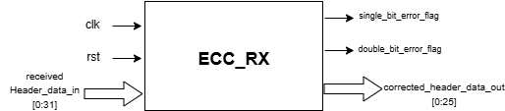
Figure 1 ECC Checker Block Diagram
4.4 Timing Diagram
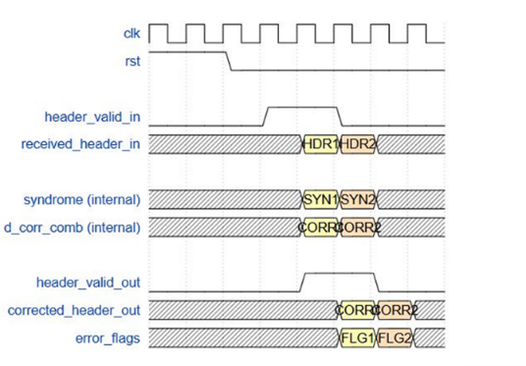
Figure 2 ECC Checker Timing diagram
4.5 Verification Requirements
- Zero-Error Validation: Feed the module mathematically perfect 32-bit headers and verify that o_err_status remains 2'b00 and the output data perfectly matches the input data.
- Exhaustive SEC Testing: Iterate through all 24 data bit positions and all 6 ECC bit positions, intentionally flipping exactly one bit per test. Verify that o_err_status flags 2'b01 and o_corrected_di / o_corrected_wc reflect the original, uncorrupted values.
- DED and Multi-bit Testing: Inject 2-bit, 3-bit, and random multi-bit errors into the 32-bit header. Verify that o_err_status definitively flags 2'b10 (Fatal Error) for all double-bit errors, ensuring the Protocol Engine is warned not to process the corrupted length or routing data.

